VegaCOMM Module Software Development Kit Manual

VegaWARE is not responsible.for damages caused by use or programming of modules, nor do we provide warranties for the misuse of any information contained in this article.

About This Document
By providing this document, we hope it will serve to get more programmers interested in creating new and exciting add-ons to VegaCOMM’s functionality. This document contains enough information to get started in creating new modules with full explanation of how to set them up to communicate with VegaCOMM and listing all functions needed for VegaCOMM to access a module. Support for creating modules is available for Visual Basic 6 only at this time and only for code provided in this article (time permitting). We do not have the time to help with questions like ‘How do I show a form in my module?’ or any other question that does not involve the provided functions that VegaCOMM and the module use to communicate. Support for such questions can be found in books, source code sample web pages, and programming message boards.

Module Basics
What is a VegaCOMM Module? A VegaCOMM Module is a program that exists outside the main VegaCOMM application that provides new functionality to VegaCOMM. It can be anything from a simple client side that tells you what time it is, to even something as complex as a multi-player game.

What do I need to create my own VegaCOMM Module? All you need is a good idea for a module, this SDK, and a programming language that allows you to create Windows ActiveX DLL’s. These programming languages include, but might NOT be limited to, Visual Basic, Visual C++, and Delphi 5+. All samples are in Visual Basic 6 only so if you choose another language for your modules, it is up to you to port the code to the appropriate language syntax.

What kind of modules can I make? Really just about anything. Here are some ideas to toss around:
-A better chat room
-A multi-player game (from tic-tac-toe to even a graphical Quake type game is possible if you have the skills required)
-An interface to connect and communicate with AOL chat rooms
-Create a web interface for accessing certain VegaCOMM functions.
-A file download utility that replaces the built-in one that adds new abilities like compression.
-A video conferencing chat room with web cam and/or voice chat.
-And so much more……

Understanding How VegaCOMM And Modules Communicate
Since VegaCOMM are all ActiveX DLL’s, they of course use classes. There is only one VegaCOMM requires but you may add others.

clsVegaMod

Whenever VegaCOMM loads a module, this is the class VegaCOMM will register and set pointer to. So it must be in your module. Now before we go further lets cover the module types.

There are 2 types of possible modules. A standalone module and a communicate module. A standalone module is quite simply one that does not use the Socket interface and does nothing beyond working with the local version of VegaCOMM. A communicate module uses the Socket interface of VegaCOMM to send data over the Internet to the server or client module and accepts data VegaCOMM intercepts.

A standalone module is very simple and only requires one function for use with VegaCOMM.

Public Sub StartModule()

This procedure is called whenever a user selects your module from the Module menu. You can of course add other procedures to it and put whatever code you wish in StartModule.

Now let’s cover the more sophisticated communicate module. First it is important to understand the process VegaCOMM follows in order to communicate with the module.
Whenever data comes in to VegaCOMM, it parses it to see if the data will be used internally by use of SendCodes. We will cover these later. If it is not used internally, it will then pass the data to all installed modules. The module can then do the same check. If the module uses it, it can then process it and send new data back to the source of the original data where the process is repeated. Generally there will be 2 versions of a module, one for the client and one for the server. They both follow this same flow.
All your module needs to accept this incoming data is the following procedure:

Public Sub ProcessData(strData As String, blnMatch As Boolean, strLogEvent As String, lngSocket As Long)

Here is the meaning and use of the parameters:
strData – This is the data VegaCOMM receives via the Internet connection and passes it into the module for processing
blnMatch – This is a simple true/false variable. Set it to true if your module will be using the data
strLogEvent – If the module is a server module and you would like to write some output to the server’s Output Log Window, set this variable to what you want to print.
lngSocket – This is the socket number the incoming data came from. Used for sending data back to the appropriate destination if applicable.

VegaCOMM SendCodes
SendCodes are what VegaCOMM uses to determine what action it needs to take. Each time VegaCOMM receives data, it is broken up into sections by use of a common delimiter. In VegaCOMM’s case, it is always “||” a double pipe. It is right under the Backspace key of your keyboard. Here is a sample line of data VegaCOMM receives

Vchat1||Halberd||Hey guys what is up?

You see the Vchat1 before the first ||? That is the SendCode. It will always be the first piece of a SendCode. In the case of this SendCode, the second part is the user name of the sender, and the third is his message to print to the Chat screen. Your module can use a code that has more or less parts as long as they are all separated by ||, the first part is the SendCode, and doesn’t conflict with an internal or other SendCode. See the SendCode list at the end of this manual for a list of all SendCodes VegaCOMM uses internally. Also it is a good idea to include a document with your module telling developers what SendCodes you use so as to decrease the possibility of conflicting SendCodes in another module.
But now that you have this string of data, how do you break it up so you can process it? There are many ways. For a way to do it in Visual Basic 6 using the Split function, see the example module below.

Sending Data Over VegaCOMM’s Sockets
This is a very important topic for modules that communicate. You may have your module setup, but how do you send data back to the destination?
First you need to get the current instance of the VegaCOMM Socket Interface.

Dim myObj As Object

Set myObj = GetObject(,”VegaCOMM.clsSocketInterface”)

It is important you use GetObject and not CreateObject to get the current running instance instead of creating a new one. See the Advanced Module SDK manual to learn how we accomplished this in Visual Basic 6 and get the code to add to your modules if you want to open it up to other modules.

Now you have it setup. Whenever you want to send data back to the originating client from the server, just use:

myObj.SendData DataToSend, Socket

DataToSend is simply what you want to send back, and Socket is the Socket number that was passed into the module’s ProcessData function.

A client sending to the server is the same except you omit the Socket parameter.

myObj.SendData DataToSend

Please refer to the Advanced Module SDK manual for information on using this in connection with the Users Module to send to multiple clients from the server.

A Sample Server Side VegaCOMM Module
Now that you hopefully understand enough about how VegaCOMM modules work, lets create a small sample one. We will assume a client side module is running. In this module, the client uses it to send a quick message to the server’s administrator. We won’t cover the client one now. This example for the server should be enough. You can get the source for both in the Samples directory of the SDK.

Getting started
First start a new ActiveX DLL project.

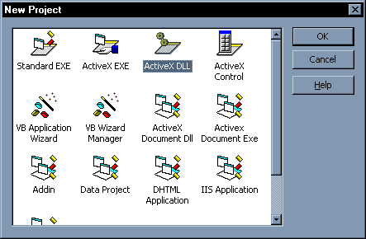
You should now have a new ActiveX DLL project open that will look like this
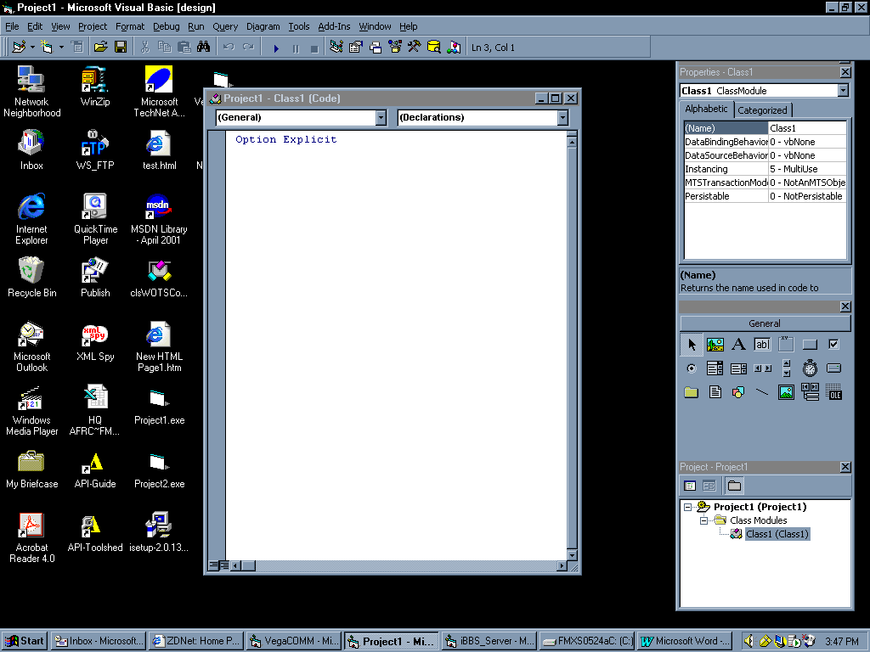

As you can see, we have a Class already up to use. We need to rename it to the class name VegaCOMM uses. Rename Class1 to clsVegaMod

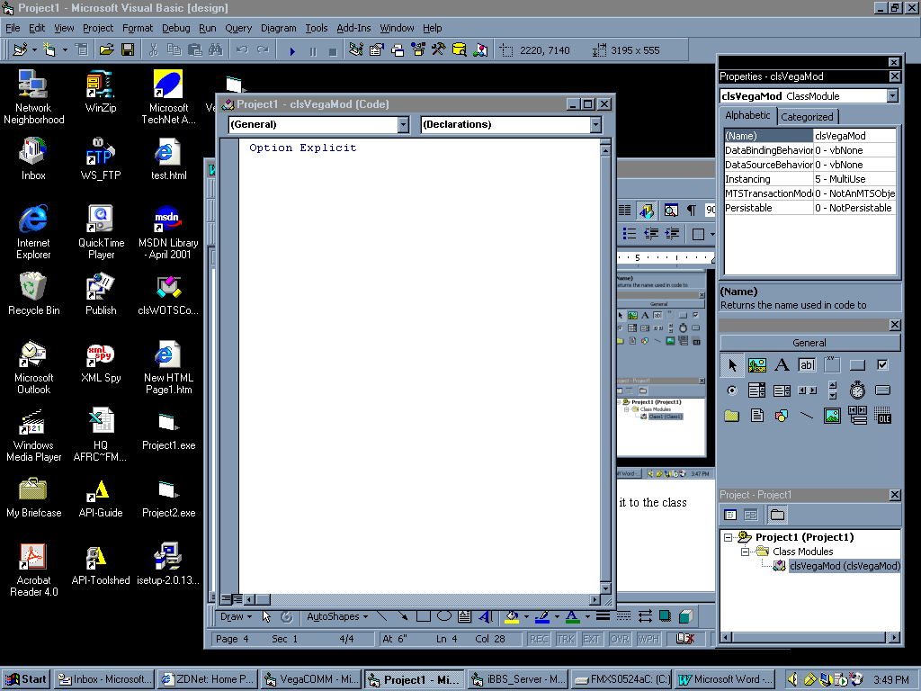

Next lets rename the Project. On the project menu, select Project then Project1 Properties…
You should see this window:
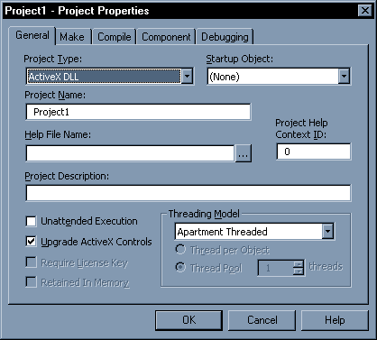
Where it says Project Name. Rename it to whatever you wish. We will use MSG1 for now.
As an extra, you can add comments about your module here:
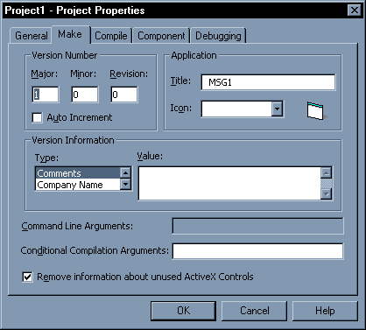
These comments are read by VegaCOMM in the Module Administrator and give someone installing the module and idea of what it is for. This is not necessary but it is a recommended courtesy.

Now we want to add our ProcessData function.
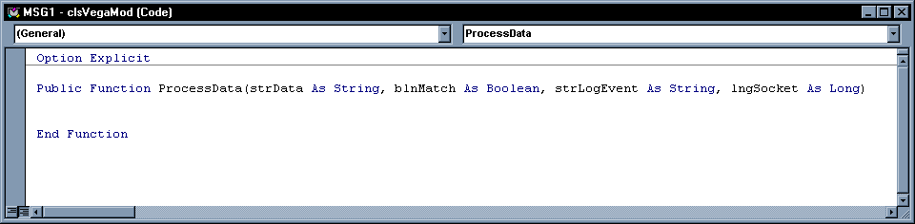
Here are the assumptions. The client is connected to the 3rd Socket and the incoming data is:

MSG1||Hello admin!

The MSG1 is the SendCode the module will check for and the rest after the || is the message.
The VegaCOMM server receives the data and sends it all in.

Now we need to see if the incoming data has a SendCode of MSG1 and if it does display the message in a message box

Dim vntSplitData
Dim strSendCode As String

' Split up incoming data
vntSplitData = Split(strData, "||")
strSendCode = vntSplitData(0)

If strSendCode = “MSG1” Then
Msgbox vntSplitData(1)
End If

And that’s is it. Simple right? Just compile and install and its done.

You can find more sophisticated sample in the Sample Modules directory if you still need to see some more samples.

Running Modules From The Menu
In some modules you may, especially in client side ones, want to open a main form or window for either the starting point of the modules communication process (perhaps the game window in the case of a multi-player game) or maybe just a configuration screen for the module on the server side.
When a module is installed, it is also added to the Modules menu on the VegaCOMM GUI. If you need a window opened when your module is selected from this menu, you can use the

Public Sub StartModule()

Procedure like we showed you before. Nothing much to explain here. Just add it to your module in the clsVegaMod class and whatever code you need it to do.

Closing Tips
-If your module is client and server side. Make a separate DLL for each and name them differently for those cases where someone may have the client and server running on the same machine. In this case, a conflict will occur and they will not work or may even crash.
-Find out the SendCodes of popular modules so as to not conflict with those. Check the module's documentation or contact the author.
-Remember to always have the SendCode as the first part of the data and delimited by || (double pipes). This is for consistency between all modules.
Get Started
That about covers all the basic information. Just come up with your good idea for a module and get to work on it. Also check the Advanced Module SDK Documentation to learn how to access the logged on user information and making your module open to be read by other modules.

Got questions? Maybe something I forgot to add? Ask me. I will answer ASAP time permitting
Vdraken@yahoo.com

APPENDIX

VegaCOMM Internal SendCodes
Vchat1
Vfile1
VPM1

